**How to make GitHub Page for your repository**

1. Go to setting of your project repository.

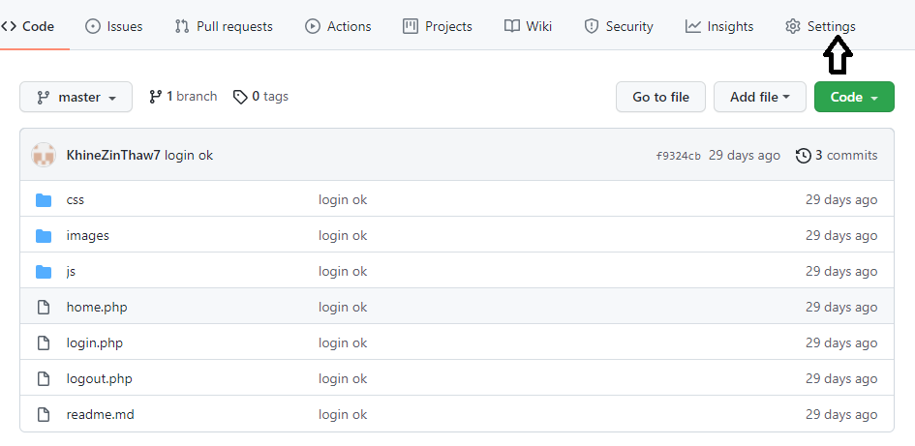

1. To create a GitHub page, click “Check it out here!” link.

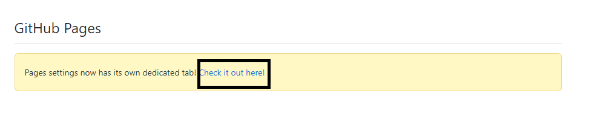

1. Select a branch for your repository and click the save button.

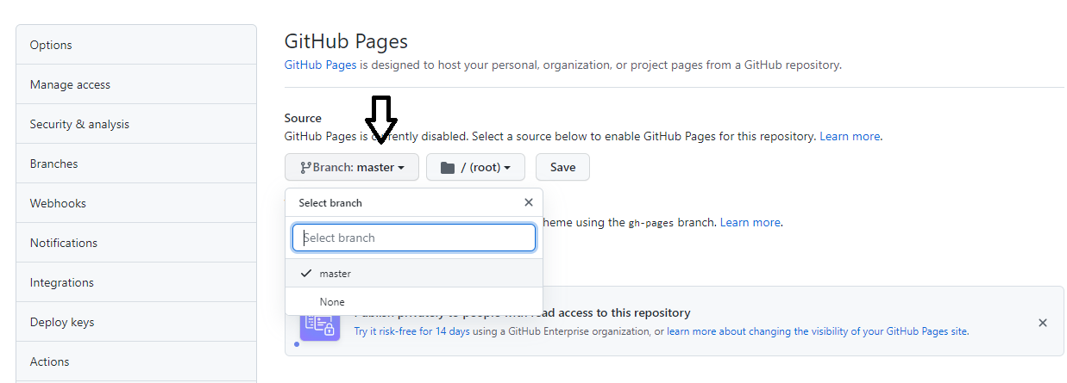

1. This is the demo link for your project.

